Evaluating the Usability of Interactive Digital Television Applications

line 1: 1st Given Name Surname   
line 2: *dept. name of organization   
(of Affiliation)*  
line 3: *name of organization   
(of Affiliation)*line 4: City, Country  
line 5: email address or ORCID

line 1: 4th Given Name Surname  
line 2: *dept. name of organization*  
*(of Affiliation)*  
line 3: *name of organization   
(of Affiliation)*line 4: City, Country  
line 5: email address or ORCIDline 1: 2nd Given Name Surname  
line 2: *dept. name of organization   
(of Affiliation)*  
line 3: *name of organization   
(of Affiliation)*line 4: City, Country  
line 5: email address or ORCID

line 1: 5th Given Name Surname  
line 2: *dept. name of organization   
(of Affiliation)*  
line 3: *name of organization   
(of Affiliation)*line 4: City, Country  
line 5: email address or ORCIDline 1: 3rd Given Name Surname  
line 2: *dept. name of organization   
(of Affiliation)*  
line 3: *name of organization   
(of Affiliation)*line 4: City, Country  
line 5: email address or ORCID

line 1: 6th Given Name Surname  
line 2: *dept. name of organization   
(of Affiliation)*  
line 3: *name of organization   
(of Affiliation)*line 4: City, Country  
line 5: email address or ORCID

***Abstract***—**Applications for Interactive Digital Television (IDTV) are becoming increasingly popular. Users no longer interact only with software applications on computers or smartphones, but also through a television set. Therefore, it is necessary to address and ensure the satisfaction, efficiency, and effectiveness that users may experience when interacting with those applications. This paper proposes an Application Usability Model for DTV based on two approaches: the quality of the software product and the quality in the use of the software product. The model is based mainly on the ISO/IEC 25010 standard in which a set of usability characteristics are defined. These characteristics have been divided into sub-characteristics, attributes, and metrics of the IDTV to quantify each attribute and to identify the usability problems that might exist. Besides, to have a better idea of how the evaluation should be performed, an example applying the proposed usability model on a weather application designed for IDTV is presented.**

Keywords—Evaluation, Usability, Interactive Digital Television, Feature, Metric.

# Introduction

Television is seen as a mean to communicate, inform, entertain, and educate [1]. This device can be found in most homes around the world [2]; it allows interaction with various types of users. The transition from analog television to digital television (DTV) has been made in many countries [1][2][3][4]. Unlike analog TV, DTV increases the number of channels available, improves the quality of audio and video, and allows the incorporation of interactive applications [3].

Hence, interactive digital television (IDTV) enables a dialogue between the user and the device—i.e., it is the active participation of the user with the content broadcast [2]. Thus, it could be established media content flow which grows while the interaction between viewers and tv applications is produced [2][5]. IDTV allows interaction with different platforms such as communication systems, mobile devices, among others [1].

An IDTV application provides three types of services: i) information services that are related to the broadcasted programs, ii) broadcast programming services, and iii) transactional services that involve sending and receiving information [6]. These services require high quality interactions between IDTV applications and the user. Henceforth, it becomes crucial to establish a model to ensure that IDTV application users get the best interaction experience in terms of satisfaction, efficiency, and effectiveness. For instance, to evaluate the usability of applications for IDTV, a usability model based on the ISO/IEC 25010 standard [7] is proposed. The model is important because it considers and defines a set of characteristics, sub-characteristics, attributes, and metrics. All these parameters support the generation of measurable values in order to quantitatively address the quality and to identify existent problems, always with reference to usability, of the different applications and their components.

The proposed model considers two approaches: the model of product quality and the model of quality in the use of the product. First, ISO/IEC 9126 refers to the usability of the product as the "*ability of software to be understood, learned, used and attractive to the user, under specific conditions of use*" [8]. Second, ISO/IEC 9241 refers to the quality in the use as the "*effectiveness, efficiency and satisfaction with which a product allows specific objectives to be reached by specific users in a context of specific use*" [9]. Some aspects must be considered here, in particular the available devices that the viewer has to interact with the applications for example remote control, second-screen devices, among others.

On the other hand, an accurate development of interactive applications is required to improve the user experience [4]. During the development of applications, it is essential to use diverse models, techniques, and principles focused on users of IDTV[10]. It is important to acknowledge users with limited or no experience in the handling of new technologies. Those users might perceive them as difficult to use and assume that the operation of an IDTV application is different from that of a computer or mobile device application [10]. In this context, as mentioned before, it is necessary to create a model for evaluating the usability of IDTV applications. This model can guide the development process so it concentrates on providing meaningful and relevant experiences to users and improving those that have already been implemented.

Finally, this article has the following structure: Section 2 presents related work regarding usability evaluation methods for IDTV applications. Section 3, describes the proposed usability model and each of its parameters. Section 4 details an application example of the usability evaluation model. Finally, Section 5 draws some conclusions and discusses future work.

# Related Work

There have been several studies over the years [11] [12] [13] [14] that apply various techniques for evaluating usability. A description of the existent work is presented below.

On one hand, [11] introduces a proposal based on a previous usability evaluation method (UEM) that integrate collaborative processes, which according to the authors, allow obtaining results richer in content than traditional UEMs. They propose three different evaluation variations, which depend on two factors: the objectives of the evaluation and the desired results. The variations are: i) global evaluation: analyzes an IDTV application in a complete way using heuristic evaluations, constructive interactions, and interrogation methods. ii) specific evaluation: analyzes specific functionalities of the IDTV application through heuristic evaluations, formal experiments, and interrogation methods, and iii) complete evaluation: more in-depth analysis than the previous ones, making use of each of their techniques.

On the other hand, [12] proposes an evaluation of IDTV applications based on specific tasks that are broken down into generic tasks that must be executed by a user. The objective is to measure the effectiveness, efficiency, and satisfaction of the level of usability of an application in relation to the definition of specific tasks. Usability testing can be done on menu layouts, multiple video screens, content display areas, pagination, and scrolling, among others.

Additionally, in [13] the authors seek to examine universal access to IDTV applications by evaluating how accessible, usable, and compelling IDTV application user interfaces are within the television experience. They use a collection of constructs and quantitative measurement instruments obtained by combining research on affective Human-Computer Interaction (HCI) and media studies, considering: unique characteristics of the television environment, the television audience, and the context of use. However, this evaluation focuses on the user interfaces obtaining general quantitative results of effectiveness and the affective capacity of the interface.

Furthermore, to evaluate the usability of IDTV applications, [14] presents a set of heuristics divided into three groups: design and aesthetics, flexibility and navigation, and errors. To analyze each heuristic, it is necessary to fill out a template specifying information related to the heuristic such as identification, name and definition, examples, benefits, and problems. The evaluators assess the interface through the proposed heuristics, for this, it is necessary to establish usability problems, assign points to each problem according to its severity from 0 (less frequent) to 4 (more recurrent), sum the results, and classify the problems according to their criticality.

The proposals mentioned above are different from the one presented in this work because they do not require the active collaboration of the user through experiments and methods of interrogation or they concentrate on general aspects of the interfaces.

Contrarily, the model presented in this work obtains quantitative results of specific characteristics and attributes of both the quality of and the quality in the use of IDTV applications. Those parameters are based on the ISO/IEC 25010 standard, which has not been used before, and provide a clear picture of what will be evaluated. The evaluation will help to determine whether an application is usable or not. Moreover, both the developers and the users themselves can perform the evaluation.

# Usability Model for IDTV Applications

In this section, the usability model for IDTV applications is presented along with a brief description of the sub-characteristics, attributes, and some metrics. For reasons of space, only the most relevant attributes of each sub-characteristic will be described. The complete model is available at the following URL <https://drive.google.com/file/d/1MJMZi1mE51Kxkxb03Z7cXbV2sRUl4bMa/view>.

This model is an adaptation of the model presented in [15], the model covers usability concepts, attributes, and metrics applied to the field of Mashups. Besides, it contains 6 sub-characteristics of the ISO / IEC 25010 standard [15]. The definitions have been modified to apply to the field of Digital Television.

Regarding the usability of the product, each of the sub-characteristics come from five of the six recommended features for usability in the ISO/IEC 25010 standard [7]: *intelligibility*, *learning*, *operability*, *protection against user errors*, and *aesthetic*. The remaining feature is *accessibility* and it was not consider because it focuses on the ability of users with certain limitations to perform IDTV applications tasks [7]. Conversely, the proposed method focuses on the common user.

In relation to the product itself, it is necessary to add a *satisfaction* characteristic to evaluate quality according to the level of user satisfaction. The final six characteristics and their sub-characteristics are depicted in Figure 1.

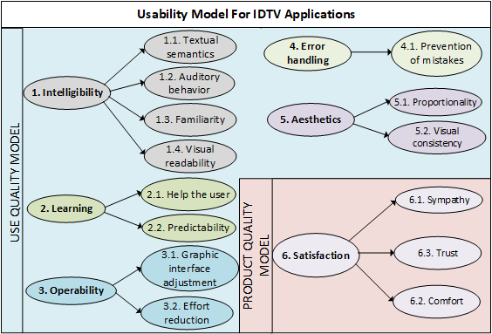

Figure 1. Characteristics and sub-characteristics of the model for evaluating the usability of IDTV applications

## Intelligibility

Intelligibility allows the user to understand if the application is adequate to meet their needs [7]. Its sub-characteristics and attributes are detailed below and also listed in Table I.

1. *Textual semantics* represents the level of understanding of the displayed text.
2. *Auditory behavior* is the presentation of images synchronized with sound.
3. *Familiarity* is the interaction of the user with the graphic interface and its elements. It contains the following attributes: internationalization and component popularity.
4. *Visual readability* refers to the visual aspects that make an application suitable for the user. It contains the following attributes: density of the displayed information, the layout of components on the screen, and the size of the components.

The layout of components on the screen attribute reflects the viewer's satisfaction with respect to the location of the components on the screen. The metric applied consists of a Likert scale valued between 0 to 1 where 0 reflects and overloaded screen and 1 shows that application doesn't influence on the tv programs

The *size of the components* attribute refers to the fact that the objects shown do not cause an overloaded presentation that hinder visual understanding. The associated metric refers to the ratio of the number of components with the appropriate size among the total number of components. A result of 0 reflects a greater usability problem, while a result of 1 reflects the opposite.

TABLE I. Sub-characteristics and Attributes of Intelligibility

| Sub-characteristics | Attribute | Meaning |
| --- | --- | --- |
| 1.1 Textual semantics | 1.1.1 Understanding textual information | Is the textual information presented coherently and is it easy to find in the message that is desired to transmit? |
| 1.2 Auditory behavior | 1.2.1 Sound and images synchronization | Are the audio and video images synchronized (no lag)? |
| 1.3 Familiarity | 1.3.1 Internationalization | Are the available actions to navigate the application similar to the ones commonly used? |
| 1.3.2 Component Popularity | Are the components presented easily recognized because they have been accepted and commonly used? |
| 1.4 Visual readability | 1.4.1 Density of the displayed information | Is the amount of information presented on the screen adequate? |
| 1.4.2 Layout of components on the screen | Are the components easy to find and recognize? |
| 1.4.3 Size of the components | Is the size of the components suitable for a viewing? |

## Learning

Another usability characteristic is learning, which allows the user to easily learn the content of the application [7]. It has two sub-characteristics which are shown in Table II and described below.

1. *User Help* represents the ability of the application to provide help to the user.

The *help on how to use the buttons* attribute refers to the information of the functionalities associated with each button so that users always have in mind what they are allowed to do. The associated metric corresponds to the ratio of the number of buttons that have a description of the activities they perform among the total number of buttons available in the application. A response of 0 represents a greater usability problem; an answer of 1 indicates there is no problem.

The attribute *expressiveness the of labels associated with the media* refers to a label that defines the functionality of the associated medium to allow consistent navigation and rapid learning by the user [16]. The associated metric consists of the relationship between the number of expressive labels associated with the media and the total number of labels associated with the media. A response of 0 represents a greater usability problem, and a result of 1 indicates there is no problem.

1. *Predictability* represents the expression level of the graphical interface to define the actions of each component.

The attribute *predictability of component actions* refers to the ease of determining what action will be executed if a component shown on the TV screen is used. Its metric is associated with the relationship between the number of components with foreseeable actions and the total number of components. A response of 0 represents a greater usability problem, while 1 indicates there is no problem.

TABLE I. Sub-characteristics and Attributes of Learning

| Sub-characteristics | Attribute | Meaning |
| --- | --- | --- |
| 2.1 User help | 2.1.1 Help on how to use the buttons | Is there information provided to the users about the actions to be executed when using a button? (Red, yellow, green button) |
| 2.1.2 Information on activities to be performed | Is there information provided about the activities necessary to perform a task? |
| 2.2.1 Expressiveness of the labels associated with the media | Is it easy to foresee that a concept is associated with a label of an element of the interface? |
| 2.2 Predictability | 2.2.2 Predictability of component actions | Is it easy to predict the action a component performs? |
| 2.2.3 Determination of possible permitted actions | Is it easy to determine the actions allowed by the application? |

## Operability

This characteristic refers to the capacity of the application that allows the user to operate and control it easily [7]. Table III presents the sub-characteristics and attributes related to operability, which are also detailed as follow.

1. *Graphic interface adjustment* is an automatic interface adjustment to any screen size or device.
2. *Effort reduction* checks that the effort made by the user to complete a task is the minimum possible.

The attribute *minimum actions* refers to everything that facilitates the use of the application, allowing to quickly execute certain actions—i.e., managing shortcuts so the user operates the application more quickly and easily [16]. The associated metric refers to the relationship between the number of actions required to complete a task using shortcuts with the number of actions without shortcuts. A result of 0 has a minor usability problem, 1 the opposite.

TABLE II. Subcharacteristics and Attributes of Operability

| Sub-characteristics | Attribute | Meaning |
| --- | --- | --- |
| 3.1  Graphic interface adjustment | 3.1.1 Auto-adjustment of the interface to various screens | Can the graphic interface be auto-adjusted to screens of different sizes without damaging the visualization of its components? |
| 3.2 Effort reduction | 3.2.1 Minimum actions | Are there mechanisms that allow carrying out a task where the user performs few actions? |

## Protection against user errors

This characteristic refers to the ability of the product to protect users from making mistakes [16]. Table IV (a) shows the sub-characteristics and attributes related to protection against user errors.

The sub-characteristics *Prevention of Errors* has the *restriction of non-necessary functions of the remote-control* attribute. It is necessary to consider that having a small and limited number of functionalities available to interact with the application improves usability because the user does not have to remember the operation of each button of the remote control.

TABLE III. Subcharacteristics of Protection Against User Errors And Aesthetics

| Sub-characteristics | Attribute | Meaning |
| --- | --- | --- |
| **(a) Protection against user errors** | | |
| 4.1 Prevention of errors | 4.1.1 Validation of data entry | How much data entered into the application has any errors? |
| 4.1.2 Restriction of non-necessary functions of the remote control | Is there a small and limited number of functionalities available to interact with the application? |
| **(b) Aesthetics** | | |
| 5.1 Proportionality | 5.1.1 Ratio of Size between elements and screen size | Is the area occupied by a component correctly related to the total area of the application on the screen? |
| 5.2.1 Coherence in the grouping of components | Are the components grouped according to the purpose they must fulfill? |
| 5.2 Visual consistency | 5.2.2 Uniformity of colors | Are the background colors used consistently in all sections of the application? |
| 5.2.3 Contrast colors | Is the level of brightness and colors of the components ad-equate? |

## Aesthetics

Table 4 (b) presents the sub-characteristics and attributes related to Aesthetics. This feature refers to the ability of the user interface to please and satisfy the viewer [7].

The attribute *Coherence in the grouping of components* refers to the fact that the components must be grouped in contiguous zones of the screen according to the actions they execute (for example, those components with similar activities or those whose execution precedes the execution of another component). The associated metric corresponds to the relationship between the number of coherently grouped components and the total number of components. If the result is 0, there is a greater usability problem, if it is 1, there is no problem.

## Satisfaction

It is also necessary to establish a quality model to evaluate the quality in use of the applications for IDTV considering the devices through which the user can interact with said applications. It was considered to evaluate the quality in use in terms of the satisfaction achieved by the user.

Table V presents sub-characteristics and attributes of Satisfaction. This characteristic refers to the degree to which users feel satisfied with the experience of using a product in a context of specific use [9].

The *Results Waiting Time* attribute refers to the waiting time between the execution of an action and the presentation of results. The associated metric states that it will have a value of 0 if the response time is greater than or equal to 10 seconds, it is 0.2 if the response time is between 5 and 10 seconds, 0.4 if it is between 2 and 5, it will be 0.8 if the response time is between 0 and 1, and lastly, it will be 1 if it is less than or equal to 0. It is considered a metric of 0 as a major usability problem and 1 as the best result.

TABLE IV. Subcharacteristics of Satisfaction

| Sub-characteristics | Attribute | Meaning |
| --- | --- | --- |
| 6.1 Sympathy | 6.1.1 Compliance on the behavior of the application | Does the user feel comfortable with the tasks that are al-lowed to perform in the IDTV application? |
| 6.2 Comfort | 6.2.1 Navigability between available functions | What is the level of compliance achieved when using the available navigation method to move from one functionality to another? |
| 6.2.2 Text input modes | How much time does it take for a user to enter text into the application? |
| 6.3 Trust | 6.3.1 Consistency of the result | Are the results presented adequate? |
| 6.3.2 Results waiting time | How long must a user wait for the results to be presented after having executed an action? |

# Application of the Usability Model

To apply to evaluate IDTV applications, consider the following:

* Select sub-characteristics, attributes, and metrics of interest from the IDTV application usability evaluation model.
* Apply the metrics in the IDTV applications to obtain the values ​​that quantify the selected attributes and sub-characteristics.
* Get a report with detected usability problems and the suggestions to solve these problems.

Then, the usability assessment model for IDTV applications is applied in two randomly chosen applications. The first application offers the display of the weather of a city or a place near the city selected by the user; The second application, [17] presents an application called QuizTV, which is a platform that allows users to enter using a username and password. This game consists of answering several questions on different topics (games, series, among others), it stores the score obtained in each category. For the implementation and execution of this applications, a virtual Set-Top-Box was used, which comes pre-installed with the Ginga environment and can be run as a virtual machine according to the recommendations given in [17].

To exemplify the application of the usability model, four attributes will be applied to evaluate the usability of these two applications, following the aforementioned process. The evaluation of each application is presented below

## Evaluation of the application to visualize the weather

Next, the usability evaluation of the application for weather visualization is presented, using four attributes with their respective metrics. Here, the objective is to generate a brief usability report. The sub-characteristics and attributes applied are: size of the components (1.4.3), Help on buttons use (2.1.1), navigability between available functions (6.2.1), results waiting time (6.3.2).

In the *components size* attribute, we apply the *ratio of the number of components with the appropriate size between the total number of components*. To apply this metric is necessary to know the number of components, or elements in the interface, with an appropriate size and the total number of components in general. There are 10 components with an appropriate size and 20 components in total. When calculating the metric obtained is 0.5.

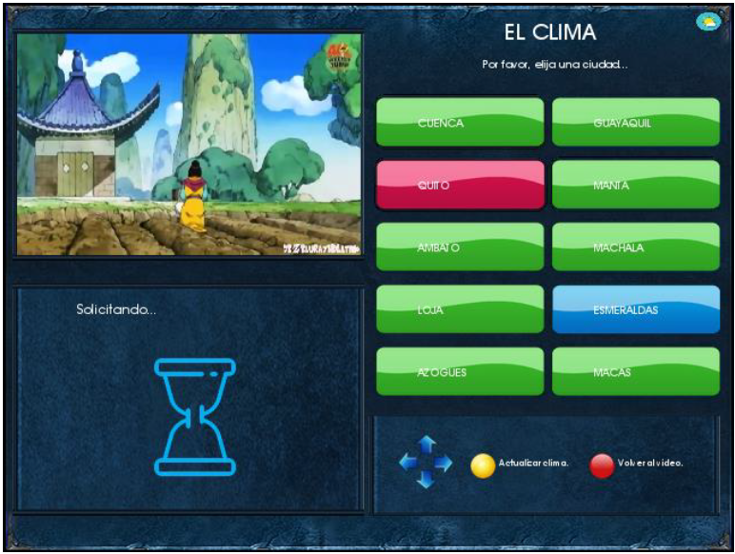

Figure 2. Weather display application for IDTV

In *help on buttons use* attribute, we apply the *ratio of the number of buttons that have a description of the activities performed by the total number of buttons available in the application*. There is a total of 2 buttons that are associated with a description of the actions performed and 8 buttons available in the application. When calculating the metric, a value of 0.25 is obtained.

To *navigability between available functions*, we apply the *comfort level navigation*. The metric is calculated by using a Likert scale with a range of 0 to 1 to indicate the level of conformity in the available navigation method. Here, 0 is the lowest level and 1 the highest to indicate the level of compliance in the available navigation method. The obtained value is 0,8.

To *results waiting time*, we calculate *the response time*. It is perceived that when applying for the weather of a city, the application takes 3 seconds to display the result, for which a value of 0.4 is assigned.

With the results obtained, a usability report can be prepared. Table 6 shows a summary of the before mentioned report together with the attributes, results, and degree of the usability issue. The levels of usability issues are described in the complete usability model introduced in section III of this work.

As seen in the results report, attribute 6.3.1 has a minor usability problem because it has an adequate inter-function navigability. Attributes 1.4.8 and 6.3.2 present a medium usability problem because, in the first instance, there are large components that occupy an area too large of the screen and, second, the response time is relatively slow. The biggest usability problem is presented by attribute 2.1.1 because there are few buttons with information about their actions compared to the number of buttons that are used in the application, which can cause the user's lack of knowledge about what should and can be done.

TABLE V. Summary of Usability Report for the First Application

| Attribute | Metric Value | Usability Issue |
| --- | --- | --- |
| Size of the components | 0.5 | Medium |
| Help on buttons use | 0.25 | Major |
| Navigability be-tween available functions | 0.8 | Minor |
| Results waiting time | 0.4 | Medium |

## Evaluation of the application called QuizTV

In the evaluation of this application, four attributes have been used with their metrics, these attributes are sound and image synchronization (1.2.1), uniformity of colors (5.2.2), consistency of the result (6.3.1) and results waiting time (6.3.2). In the end, a usability report similar to the previous case is shown.

In the *sound and image synchronization*, we apply *synchronization level perceived by the user*. Here the scale of Likert was used, where 1 means that there are an incorrect synchronization and 3 means that there is a good synchronization of the sound. The assigned value is 1 because this application does not have any type of sound; therefore, it is not possible to measure the sound synchronization when presenting images or pressing an option.

In the *uniformity of colors*, we apply the *ratio of the number of screens with similar colors on the total number of screens*. In the color uniformity, we calculate the ratio of the number of screens with similar colors in the total number of screens. This application contains 6 screens in a total of which 5 screens contain similar colors, therefore, the value obtained is 0.83. An example of a screen is the one shown in figure 3.

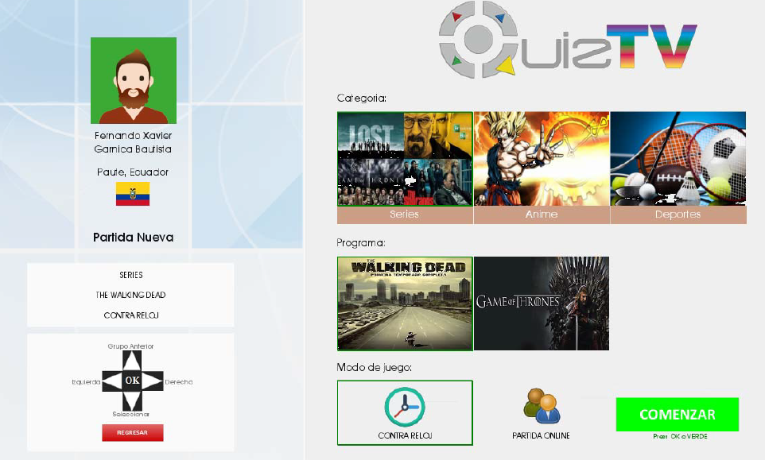

Figure 3. IDTV application called QuizTV. Fuente: [17]

In the *consistency of the result*, we calculate the c*onsistency level*. Here, the trivia has been solved several times in which the results at the end of each game have been consistent and reliable, so the Likert scale is applied where 0 means nothing and 5 means completely expected. The value obtained is 5.

To *results waiting time*, we calculate *the response time.* It is perceived that when the trivia is finished, the application takes 0.5 seconds to show the result, for which a value of 0.8 is assigned.

Table 6 presents information corresponding to the selected attributes (attribute, metric value, and usability problem). The results report shows that the attribute (1.2.1) has a major usability problem due to the fact that no sound has been included in the application, the use of sound is recommended to improve the user experience. Then the attribute (5.2.2) has a minor usability problem this means it has a good level of color uniformity between screens. The attribute (6.3.1) that has a minor usability problem because it presents reliable results both in the application entry and in the trivia results. Finally, the attribute (6.3.2) has a minor usability problem, that is, it has responded in a timely manner to the viewer's requests.

TABLE VI. Summary of usability report for the Second Application

| Attribute | Metric Value | Usability Issue |
| --- | --- | --- |
| Sound and image synchronization | 1 | Major |
| Uniformity of colors | 0.83 | Minor |
| Consistency of the result | 5 | Minor |
| Results waiting time | 0.8 | Minor |

# Conclusions and future work

This paper has presented a model for evaluating the usability of IDTV applications, which can be used to evaluate the usability of the applications that are deployed on TV. The model in question breaks down the usability characteristics proposed in the ISO / IEC 25010 standard into sub-characteristics and, at the same time, said sub-characteristics into at-tributes. It has also been defined a set of metrics associated with each attribute in order to quantify them and therefore be able to identify usability problems, whether these are major, medium, minor or none. The model is complemented with the satisfaction characteristic present in the quality of use of the product, which also considers the means of interaction with the application.

All the characteristics, sub-characteristics, attributes and metrics suggested in the Application Usability Model for IDTV refer to important elements that must be considered in applications of this field to achieve both an adequate product usability and a good quality in use. Finally, this model has been applied to evaluate two applications, obtaining a report in which some improvements are recommended to facilitate the interaction of the viewer with the application.

As future work, it has been considered the design and develop of a method of evaluation of usability of applications for IDTV in which the process necessary to carry out this evolution is detailed and, at the same time, give guidelines of how the evaluators should apply the Application Usability Model for IDTV, both from the perspective of the developer or of the buyer.

##### Acknowledgment

##### References

[1] Y. Wu, S. Hirakawa, U. H. Reimers, and J. Whitaker, “Overview of Digital Television Development Worldwide,” *Proc. IEEE*, vol. 94, no. 1, pp. 8–21, Jan. 2006.

[2] M. J. Abásolo, A. De Giusti, M. Naiouf, and P. Pesado, “Aplicaciones de la Televisión Interactiva y tecnologías afines para el mejoramiento de los pueblos latinoamericanos.”

[3] K. Palacio-Baus, M. Mejia-Pesantez, L. Munoz-Guillen, and M. Espinoza-Mejia, “Current challenges of interactive digital television,” *2017 IEEE 2nd Ecuador Tech. Chapters Meet. ETCM 2017*, vol. 2017-Janua, pp. 1–6, 2018.

[4] M. F. Miranda and S. I. Casas, “Usable and interactive application generator for Digital TV,” *Dyna*, vol. 86, no. 211, pp. 174–183, 2019.

[5] F. Fernández and S. Goldenberg, “Aplicaciones interactivas para la televisión digital en Chile,” *Cuadernos.info*, no. 22, pp. 6–17, 2008.

[6] M. F. Miranda, S. I. Casas, and C. A. Marcos, “Línea de Producto de Software para aplicaciones de TVDi basado en patrones de diseño,” *Inf. Científicos Técnicos - UNPA*, vol. 8, no. 2, pp. 1–30, Aug. 2016.

[7] “NORMAS ISO 25000.” [Online]. Available: https://iso25000.com/index.php/normas-iso-25000?limit=4&limitstart=0. [Accessed: 11-May-2020].

[8] “The ISO 9126 Standard.” [Online]. Available: https://www.issco.unige.ch/en/research/projects/ewg96/node13.html. [Accessed: 11-May-2020].

[9] “ISO 9241-9:2000(en), Ergonomic requirements for office work with visual display terminals (VDTs) — Part 9: Requirements for non-keyboard input devices.” [Online]. Available: https://www.iso.org/obp/ui/#iso:std:iso:9241:-9:ed-1:v1:en. [Accessed: 12-May-2020].

[10] V. M. P. B and J. D. C. Q, “Modelo centrado en el usuario para el desarrollo de aplicaciones de televisión digital interactiva . User-centered model for the development of interactive digital TV applications .,” no. September, 2014.

[11] A. F. Solano, C. A. Collazos, and J. L. Arciniegas, “Evaluando la Usabilidad de Aplicaciones de Televisión Digital Interactiva desde una Perspectiva Colaborativa Evaluating the Usability of Interactive Digital Television Applications from a Collaborative Approach,” no. 12, pp. 43–49, 2012.

[12] T. Kunert and H. Krömker, “Proven Interaction Design Solutions for Accessing and Viewing Interactive TV Content Items,” in *Interactive Digital Television*, IGI Global, pp. 184–206.

[13] K. Chorianopoulos and D. Spinellis, “User interface development for interactive television: Extending a commercial DTV platform to the virtual channel API,” *Comput. Graph.*, vol. 28, no. 2, pp. 157–166, 2004.

[14] and V. R. Solano, Andrés, Cristian Rusu, César Collazos, Silvana Roncagliolo, José Luis Arciniegas, “Usability Heuristics for Interactive Digital Television,” *Afin*, vol. The Third, no. August, pp. 60–63, 2011.

[15] E. Insfran, P. Cedillo, and A. Fernández, “Evaluating the Usability of Mashups Applications,” 2012.

[16] A. Solano, G. E. Chanchí, C. A. Collazos, and J. L. Arciniegas, “Directrices para el diseño de aplicaciones usables en entornos de televisión digital,” no. June, 2014.

[17] X. Garnica-Bautista, X. Maita-Tepan, M. Mejia-Pesantez, and L. Munoz-Guillen, “QuizTV: A game for interactive digital television. development considerations using the ginga-NCL middleware,” *Proc. - 3rd Int. Conf. Inf. Syst. Comput. Sci. INCISCOS 2018*, vol. 2018-Decem, pp. 246–253, 2018.